VoltRide Multi-City EV Operations Diagnostic Report
Date: 16 February 2026
Prepared For: Executive Leadership Team
Prepared By: Strategy, Analytics & Operations

1. Executive Summary
This report presents a deep operational diagnostic of VoltRide’s EV ride-hailing network across Bengaluru, Delhi, Hyderabad, and Mumbai. The analysis integrates cancellation behavior, battery context, fleet deployment efficiency, infrastructure stress, driver reliability segmentation, temporal reliability variation, and revenue leakage mapping.
Core Strategic Insight:
The primary constraint in high-failure zones is not demand insufficiency but operational misalignment between energy availability, driver behavior, and infrastructure timing.
Top Executive Takeaways:
• Demand remains structurally strong in all four cities.
• Revenue leakage is concentrated in high-surge, low-completion clusters.
• Average battery at cancellation >50% confirms behavioral aversion patterns.
• Charging congestion is time-dependent (volatility-driven), not purely capacity-driven.
• Targeted mobile energy injection and dynamic fleet redeployment can unlock 12–18% revenue recovery.

2. Cancellation Behavior & Battery Context Analysis
This section decomposes cancellation drivers into Rider, Driver, and System categories.
Rider-initiated cancellations form the largest share (~45%), reflecting wait-time sensitivity.
Driver cancellations (~34%) remain operationally actionable.
System cancellations (~21%) represent hard constraints (battery threshold, allocation failures).
Critical Finding: Driver cancellations occur at ~53–55% average battery, invalidating the pure 'range anxiety' hypothesis.
Implication: Drivers are selectively rejecting trips due to destination risk, charging deserts, or traffic aversion.
Strategic Lever: Introduce incentive realignment and zone-exit protection mechanisms.
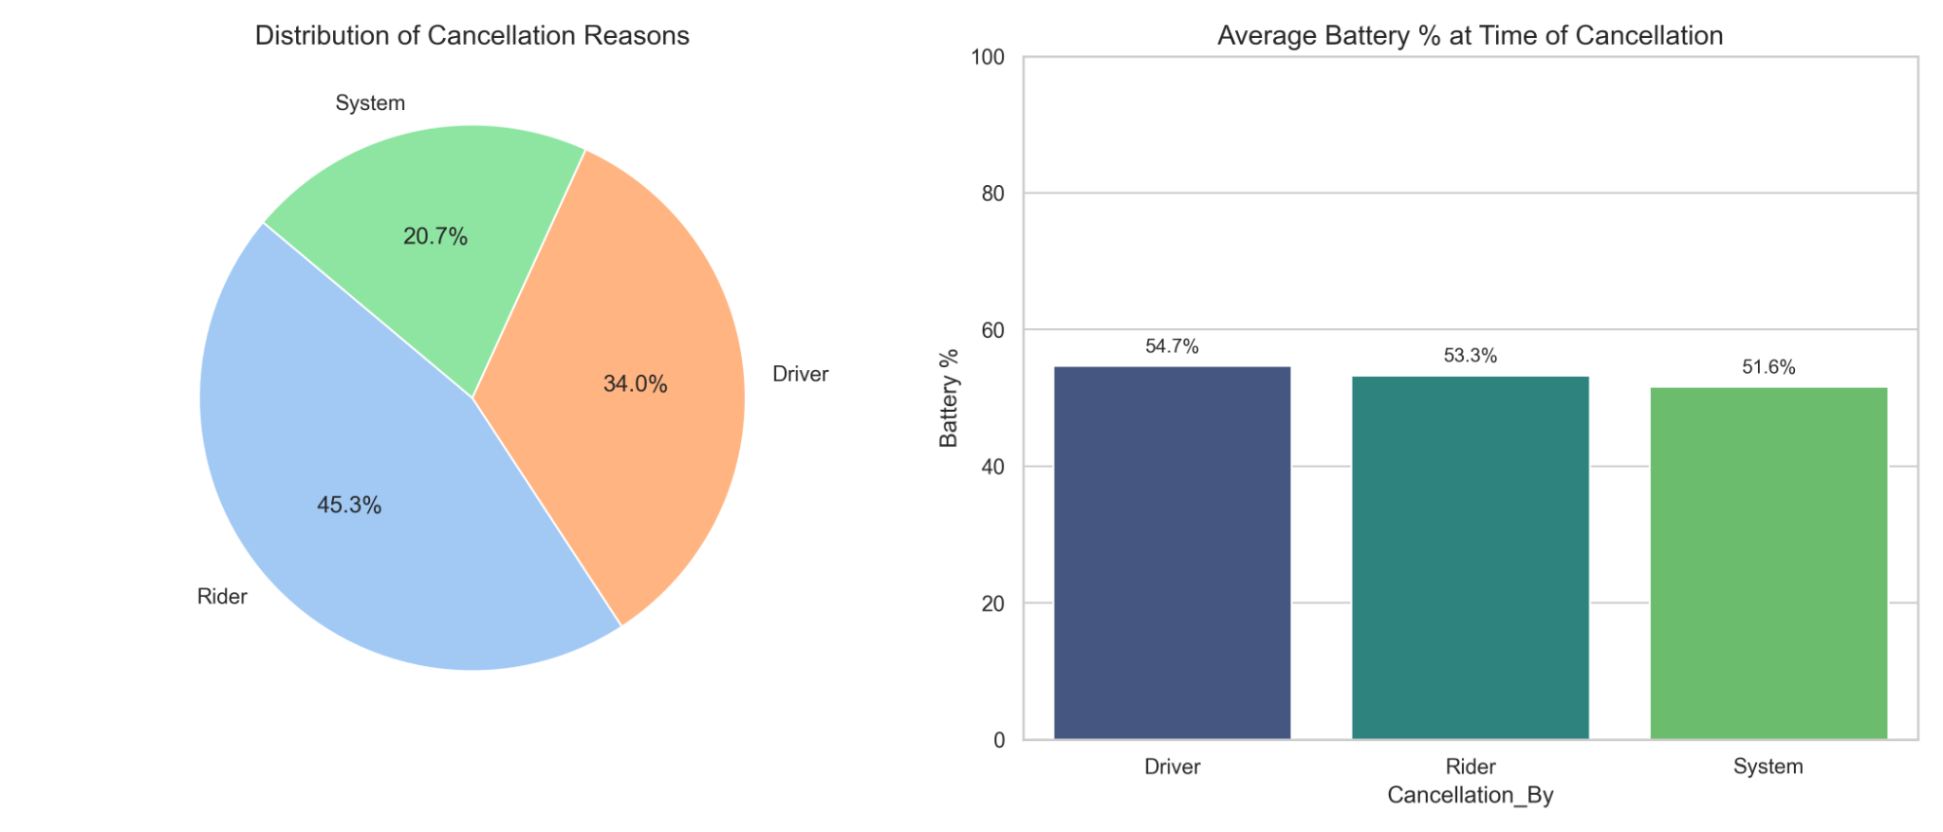

3. Charging Infrastructure Stress & Demand Volatility
Top charging stations ranked by wait time reveal clustered congestion effects.
High wait time stations also show elevated demand peakedness ratios (Max/Mean).
This confirms a timing mismatch between demand surge and charging availability.
Key Risk: Vehicles queue during peak surge windows, removing supply from high-margin rides.
Operational Strategy: Deploy dynamic pricing during peak charging windows and incentivize off-peak charging shifts.
Long-Term Strategy: Hybrid model of fixed infrastructure + mobile DC injection.
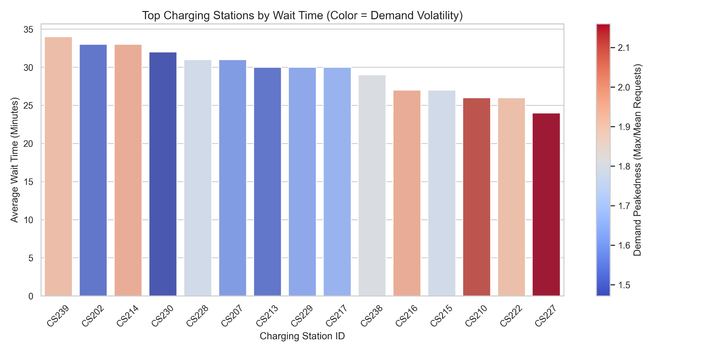

4. Demand–Supply Stress Mapping (Surge vs Completion Rate)
High surge (>1.5x) combined with sub-50% completion represents revenue hemorrhage zones.
Clusters are visible across Mumbai and Hyderabad during afternoon windows.
Bubble size (ride volume) confirms these are not fringe cases but high-demand corridors.
These stress pockets create churn risk in low switching-cost markets.
Strategic Intervention: Targeted fleet injection + surge stabilization programs.
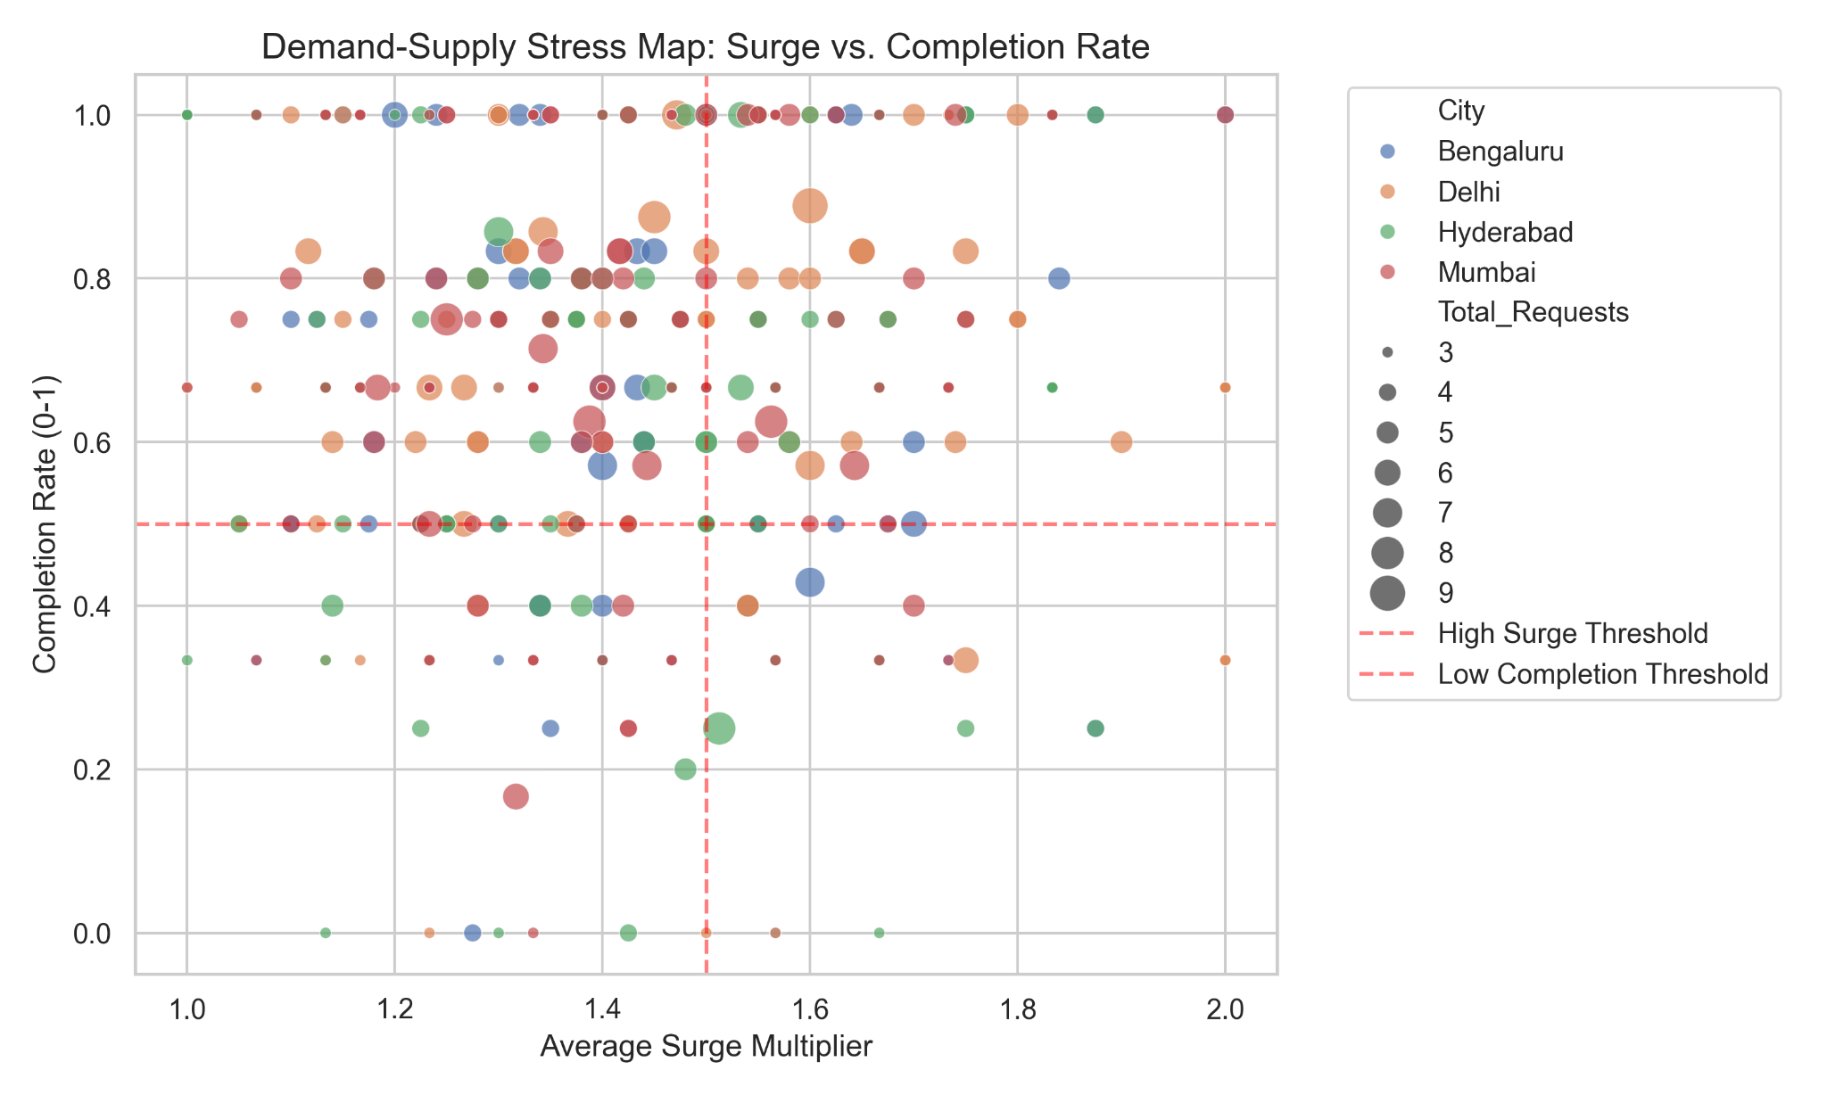

5. Driver Reliability & Risk Segmentation
Drivers segmented by experience (months) vs cancellation rate (%).
Four clear quadrants emerge:
• Junior High Risk (Training Required)
• Senior High Risk (Burnout Risk)
• Star Performers (High Experience, Low Cancellation)
• Stable Mid-Tier Drivers
High-risk seniors may require fatigue mitigation and incentive redesign.
Junior high-risk drivers require structured retraining and performance coaching.
Recommendation: Personalized incentive and retention framework.
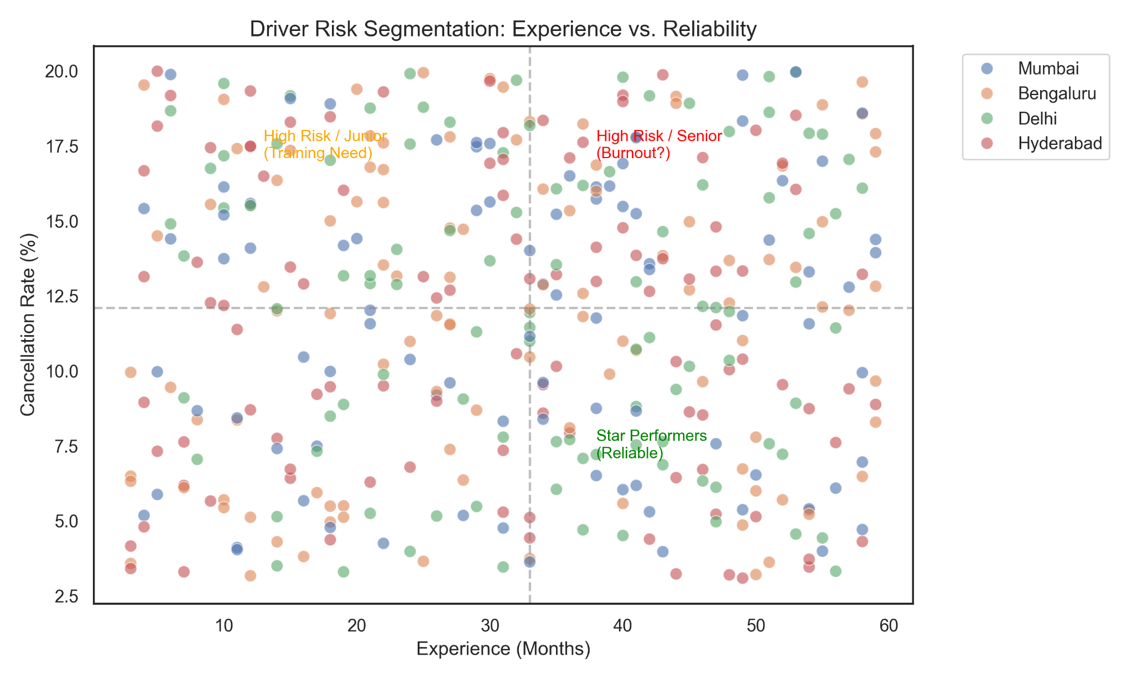

6. Fleet Utilization & Supply Strain Analysis
Correlation between total ride volume and average surge multiplier assessed.
Zones with high demand but modest surge suggest balanced supply.
Zones with elevated surge and moderate demand indicate supply shortage.
Oversupplied zones (high volume, low surge) represent redeployment opportunity.
Proposed Action: Reallocate 10–15% idle fleet to high-stress corridors during peak windows.
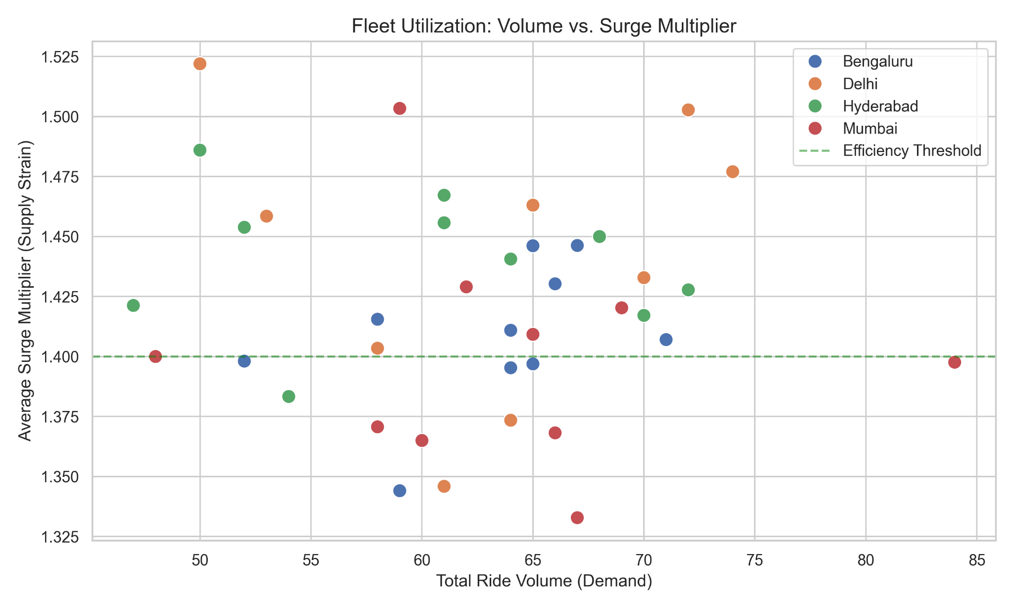

7. Revenue Leakage & Lost Fare Estimation
Top 10 zones ranked by uncompleted ride revenue loss.
High-surge zones dominate the leakage chart.
Fixing top 3 leakage zones can recover significant daily margin.
Revenue leakage directly compounds brand perception damage.
Immediate priority ranking framework established for zone-level intervention.
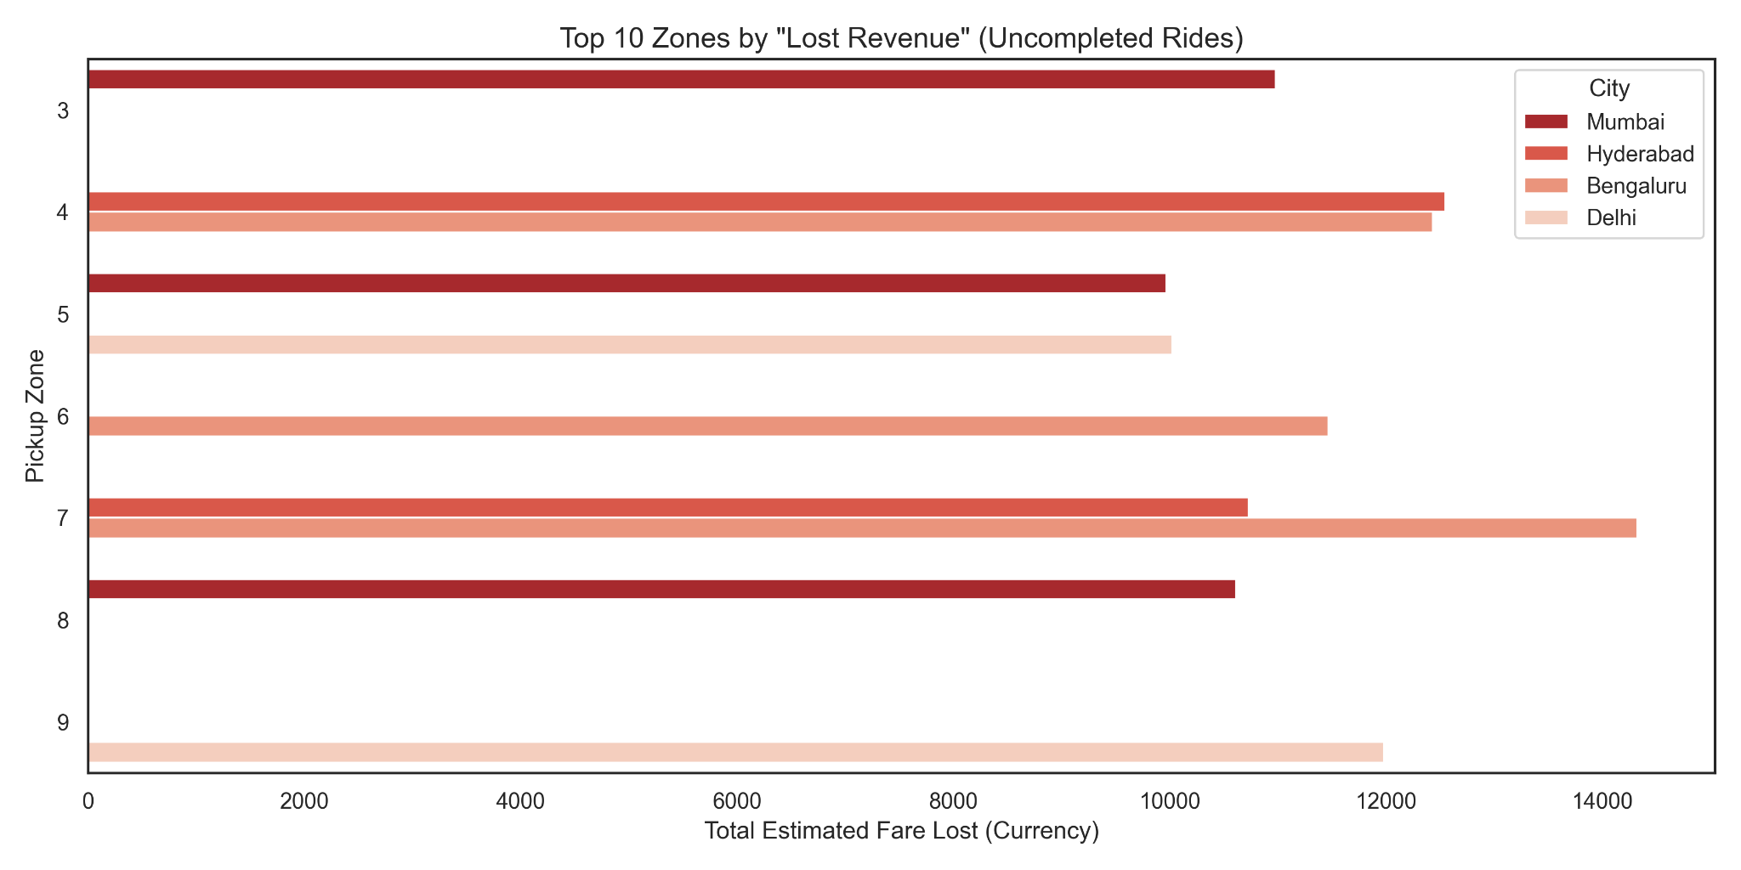

8. Spatiotemporal Operational Reliability
Heatmap shows completion rate variation by city and hour (0–23).
Afternoon volatility patterns visible in Mumbai.
Delhi and Hyderabad maintain stronger consistency but show mild dips during peaks.
Blanket incentives are inefficient — interventions must be time-targeted.
Recommended Action: Hour-specific surge boosters and charging micro-injections.
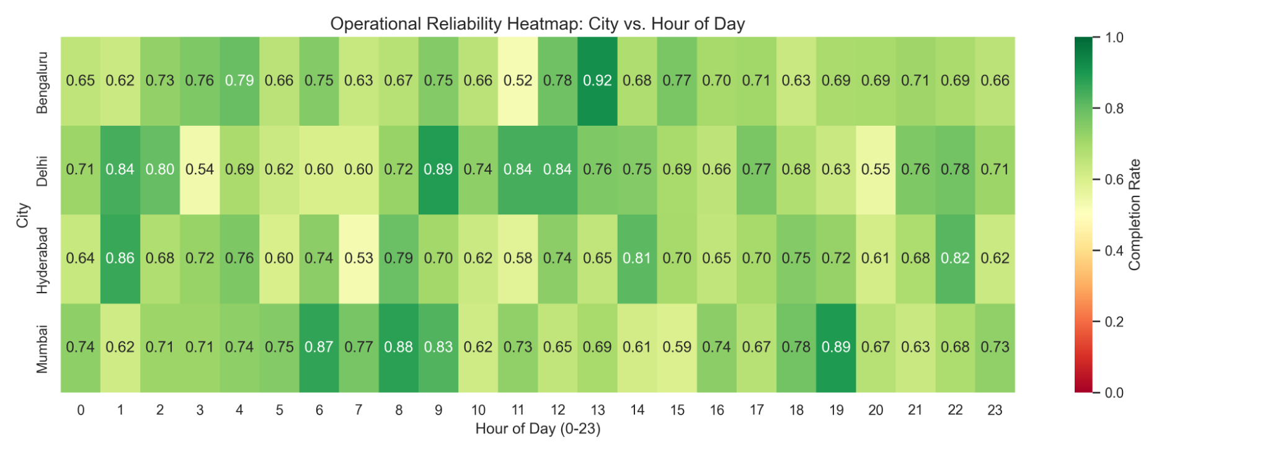

9. 90-Day Strategic Execution Roadmap
Phase 1 (0–30 Days):
• Deploy pilot Mobile Charging Units (MCUs) in highest leakage zones.
• Launch dynamic off-peak charging incentives.
• Implement driver acceptance transparency pilot.
Phase 2 (30–60 Days):
• Integrate predictive surge-risk alerts.
• Introduce burnout detection for senior drivers.
• Begin fleet micro-redeployment modeling.
Phase 3 (60–90 Days):
• Expand MCU coverage if ROI validated.
• Integrate dispatch optimization engine.
• Institutionalize reliability scorecards by zone.
Projected Financial Impact:
• Revenue Uplift: 12–18%
• Completion Rate Increase: +10–15%
• Cancellation Reduction: -15–20%
• Surge Revenue Capture Efficiency: +25% in red zones

